- Lab 01 — IAM: Identity and Access Management
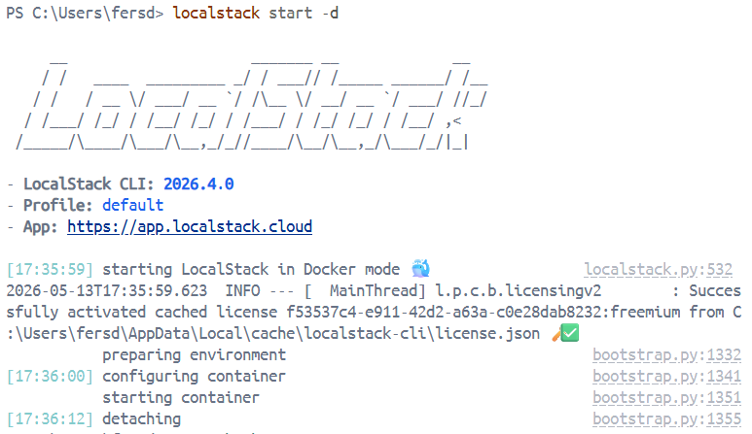

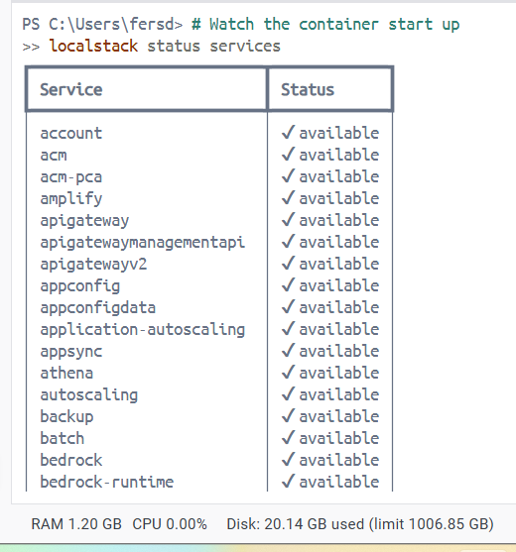

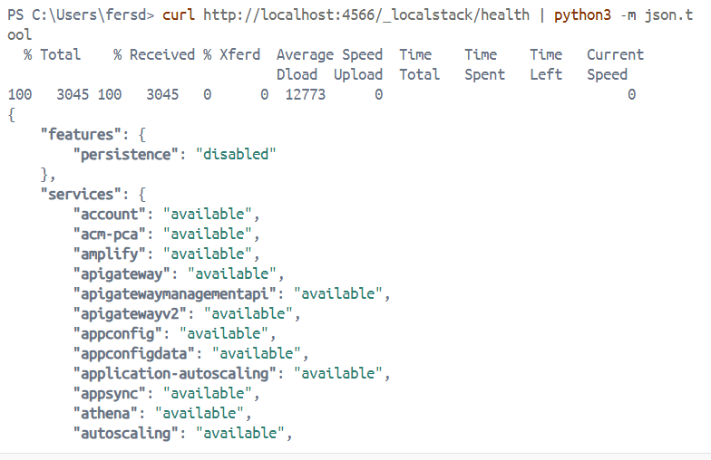

Step 6 — Create a Fake AWS Profile for LocalStack
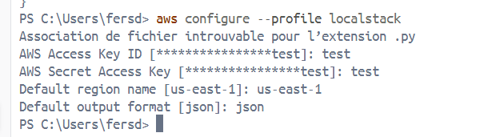

🪣 Part 4 — Your First LocalStack Resources

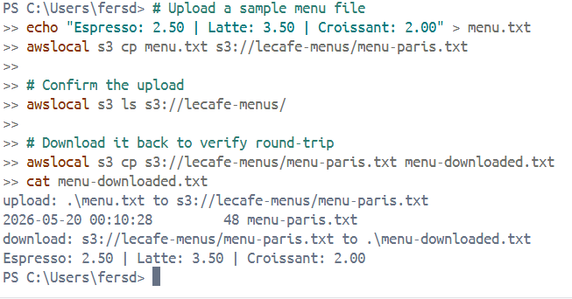
Step 8 — Create an S3 Bucket (Le Café Menu Storage)

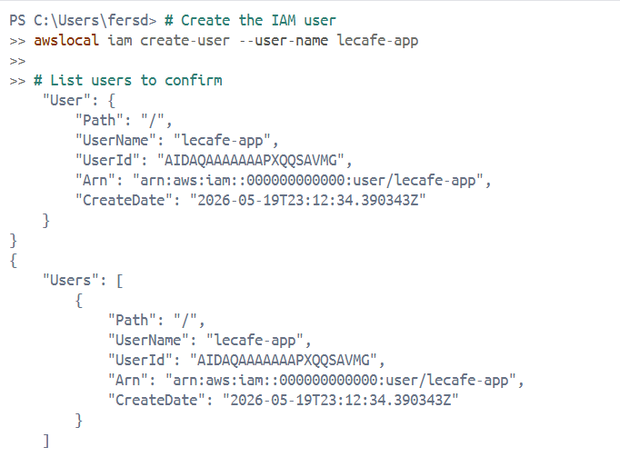
Step 9 — Create an IAM User (Le Café App User)

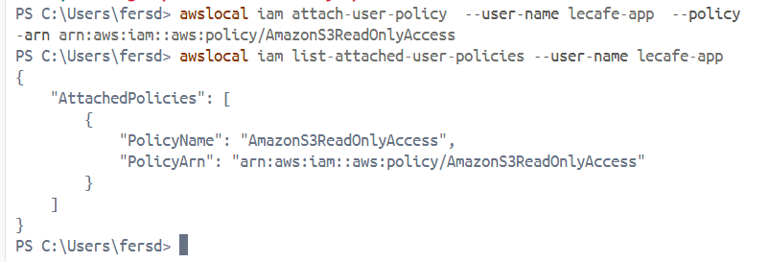

Step 10 — Create an SQS Queue (Order Processing)
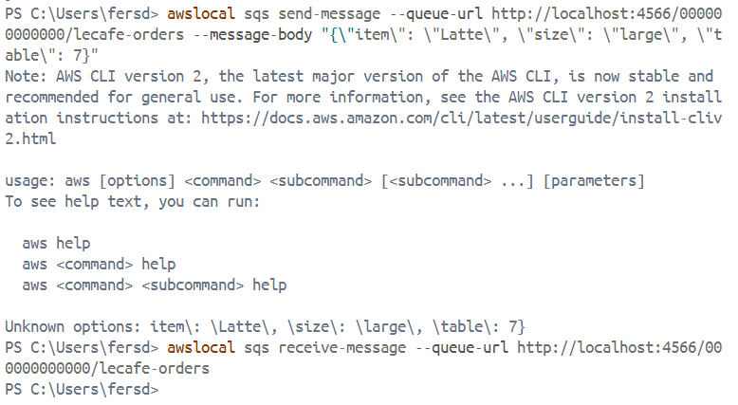

Part 5 — Inspect LocalStack Internals

Step 11 — Explore the LocalStack Dashboard (Pro Feature Preview)
